
Finals coming: be fierce!

1. Confidence Intervals and Credible Intervals

At the beginning of the course we said that statistics could be used (1) to describe data or (2) to make inferences. In the remainder of the course our concern will be inference.

The purpose of statistical inference is to draw conclusions about a population parameter (e.g., μ) based on information in a sample (e.g., $\overline{X}$). Because sample data only gives us limited information, the population inferences drawn from sample data are uncertain. We express this uncertainty as a range of likely values for some population parameter.

Confidence intervals (the classical approach) and credible intervals (a more modern approach) are two ways of expressing a statistical estimate in terms of a range of likely values. Let's consider the case of estimating a population mean based on sample data.

- A 95% confidence interval is the range of values such that, if all possible samples of size n are taken, 95% of them include the true population mean somewhere within the interval around the sample mean, and only 5% of them do not. This is an extremely convoluted and almost incomprehensible definition.
- A 95% credible interval is the range of values in which we are 95% certain a population mean falls, based on the sample mean of n cases. For example, observing a sample mean of 10, a credible interval might assert that we are 95% certain that the population mean falls between 8 and 12. This is what we want to know!
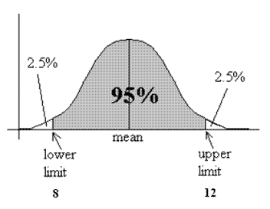
In many cases, the confidence and credible intervals are exactly the same. Therefore, even though it is not strictly correct, in practice people tend to construct confidence intervals (which are easier to produce), but they interpret them as "approximate" credible intervals. In coming years, credible intervals may become more common than confidence intervals.

Bottom line: we will follow the text in constructing confidence intervals, but in most cases will interpret them as approximate or quasi-credible intervals. (This is not a perfect situation, but it is better than any other alternative.)

2. Confidence Interval of the Mean (σ Known)

Problem: we have captured, measured, weighed, and released 100 sea otter pups in Monterey Bay. We wish to estimate the mean weight for the entire population of sea otter pups in Monterey Bay. We also know (from some other source) the population standard deviation.

Step 1. Let p be the width of our confidence interval (expressed as a proportion). This means we want a confidence interval in which we believe with (p × 100)% certainty that the true population mean falls. For example, with p = .95, we will produce a .95 × 100 = 95% confidence interval for the population mean.

Step 2. Calculate the areas in the upper and lower tail of a standard normal distribution corresponding to proportion p.

α = 1 – p
α / 2 = area in upper tail = area in lower tail

For example, if p = .95, α = .05, α /2 = .025

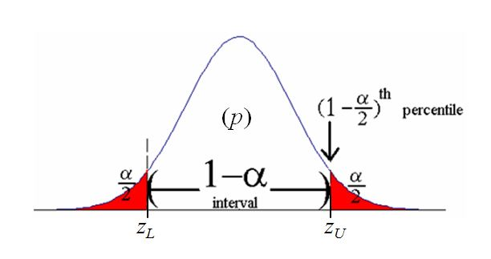

Step 3. Calculate the z-values (z_{L} and z_{U}) that define the upper and lower limits of the confidence interval:

Lower limit: z_{L} = z-value such that the proportion of the area below is α/2
Upper limit: z_{U} =z-value such that proportion of the area above is 1 – α/2.

For this, we can use the norm.inv function of Excel. For example:

z_{L} = norm.inv (.025)
z_{U} = norm.inv (.975)

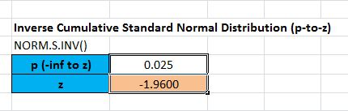

So z_{L} = –1.96 and z_{U} = 1.96.

Step 4. Convert z_{L} and z_{U} to the scale of your actual data.

Recall the formula for a z-score: and solve for X. (We will use , the sample mean in place of µ; and the standard error of the mean, instead of σ. This is because we are concerned here not with a confidence interval of the population values, but of the population mean – therefore we base our interval on the estimated variability of sample means.

Lower limit of CI =
Upper limit of CI =

Recall that is the standard error of the mean, equal to , where σ is the population standard deviation and n is the sample size.

Example: Seal otter pup weight


Suppose we've captured, weighed, and released 25 sea otter pups in Monterey Bay; their mean weight is $\overline{X}$= 750 g. Assuming the population standard deviation for seal pup weight is σ = 100 g, what is the 95% confidence interval for the population mean (µ) weight?

p = 0.95
α = 1.0 – 0.95 = 0.05
α/2 = 0.025

z_{L} = norm.s.inv (.025) = –1.96
z_{U} = norm.s.inv (.975) = 1.96

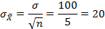

Lower limit of CI = = 800 + (–1.96 × 20) = 760.8g
Upper limit of CI = = 800 + (1.96 × 20) = 839.2g

3. Confidence Intervals of the Mean (σ Not Known)

Above we considered confidence intervals for a population mean when the population standard deviation (σ) is known. Usually σ is not known.

When σ is not known, we follow a similar procedure, but use the t distribution in place of the z distribution. This is described below.

Student's t Distribution

- 'Student' was the pseudonym of William Gosset.

- The 'Student' t distribution is like the normal distribution, but with fatter tails.

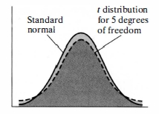

- The t distribution differs slightly according to sample size. When you use it, you must also specify the number of degrees of freedom (df).

- Degrees of freedom = n – 1 (where n is the sample size).

Confidence Interval Formulas
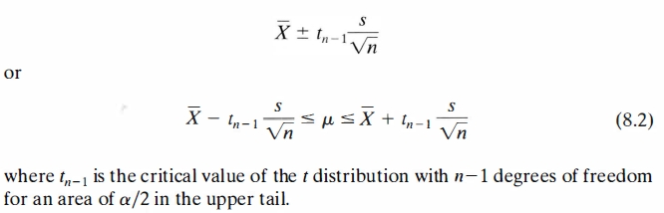

Recall that a confidence interval is defined by a lower and upper limit (critical values). In the formulas above t_{n–1} is the upper limit. To get the lower limit, add a minus sign to the lower limit.

Instead of using tables, we can compute the critical values of t_{n–1} using the Excel function T.INV.

Lower limit = T.INV.2T (α, df)
Upper limit = T.INV.2T (1 – α, df)

where df = n – 1.

Example: Super-computer coolant temperature

A computer engineer wants a 95% confidence for μ = mean temperature of a super computer's coolant at shutdown. A sample of seven readings yields: 45, 49, 55, 56, 51, 51, 46
degrees C. Then:
$\overline{x}$ = 353/7 = 50.43

.

The critical value for a 95% confidence interval is t_{n–-1} = 2.447

= 50.43 ± 2.447$\left(\frac{4\text{.}\text{16}}{\sqrt{7}}\right)$ = 50.43 ± 3.85 = (46.58, 54.28)

4. Confidence Interval of a Proportion

(Note: this section summarizes and supersedes online Lecture 15 - Sampling Distribution of a Proportion)

We can also calculate confidence intervals for a proportion. In this case we wish to estimate the plausible range of a population proportion (π) of some trait based on the observed proportion (p) of the trait in a sample of size n. For example, if out of 1000 polled voters, the proportion that approve of the president is be p = 0.44, what is the likely range for the approval rate in the entire population (π)?

Here we make use of two convenient facts. First, like a population mean, a population proportion has a sampling distribution; the standard error of this sampling distribution is:

$${\text{SE}}_{π}=σ_{π}=\sqrt{\frac{π(1−π)}{n}}$$

If we know the population proportion π, we use that in the equation above. Otherwise we use p as an estimate of π, or:

$${\text{SE}}_{π}=σ_{π}=\sqrt{\frac{p(1−p)}{n}}$$

Second, under certain conditions, the sampling distribution of a population proportion is well approximated by a normal (Gaussian) distribution. The conditions are:

- A reasonably large n (e.g., n > 50)
- 0.10 < π < 0.90

Given these conditions, we may construct a confidence interval of a proportion as:

Lower Limit = p – Z_{L} × SE_{π}
Upper Limit = p + Z_{U} × SE_{π}

However as π approaches 0 or 1 (especially with a small n), it's sampling distribution is no longer approximated by a normal curve and the above method is unsuitable:

Sampling Distribution of Proportion
(π = 0.1, n = 10)
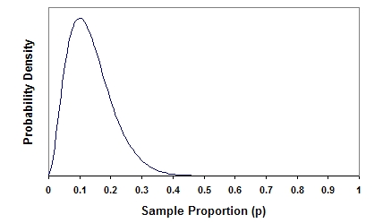

For this and other reason, computing confidence intervals of a proportion based on a normal distribution is rapidly being replaced by more exact, computation intensive methods.

There are lot's of online calculators to construct exact confidence intervals for a proportion:

http://www.causascientia.org/math_stat/ProportionCI.html

5. Homework

Read Ch. 8, Sections 8.3 (pp. 367–374) and 8.7 (p. 384). Work odd-numbered problems as necessary and check answers in back of book; bring any questions about exercises to class.

To prepare for Monday, familiarize yourself with Ch. 9, Sections 9.4 (pp. 413–420) and 9.6 (pp. 427–431).

